AI LAB TEST-01
Hall ticket number:2403a53057
Batch number:18

1.Create a Python function that converts an amount from one currency to another using exchange rates stored in a dictionary. Use GitHub Copilot along with VS Code. Use Few shot prompting.
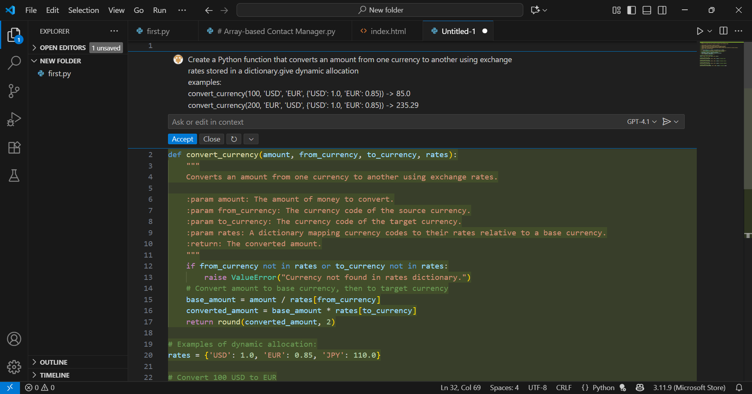
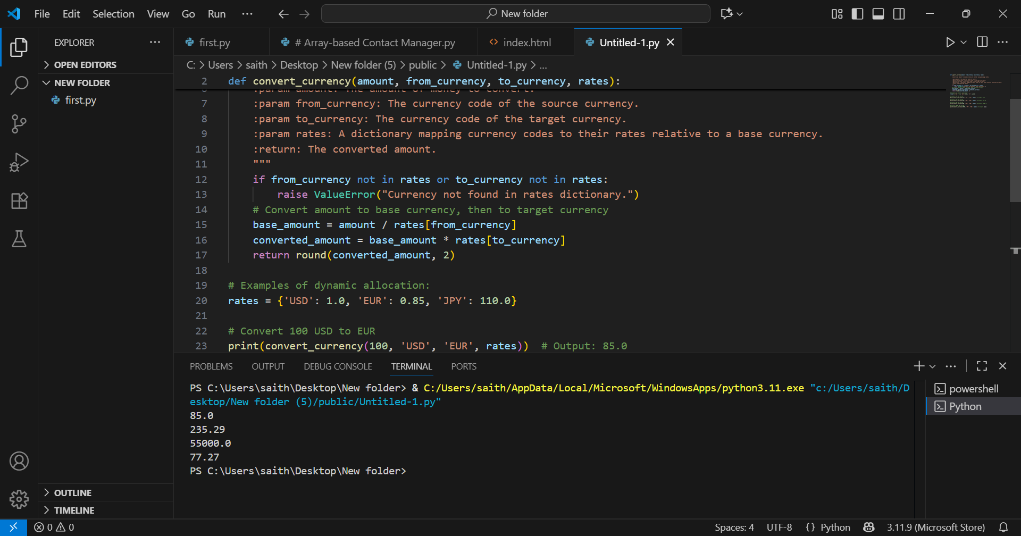
2. Write a Python program to extract all email addresses from a block of text using regular expressions. GitHub Copilot along with VS Code. Use zero shot prompting
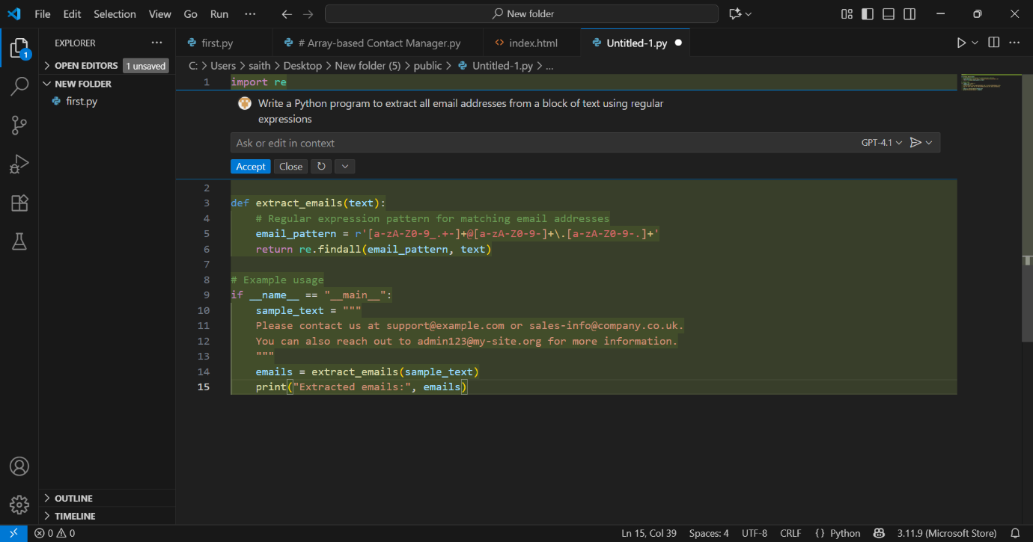

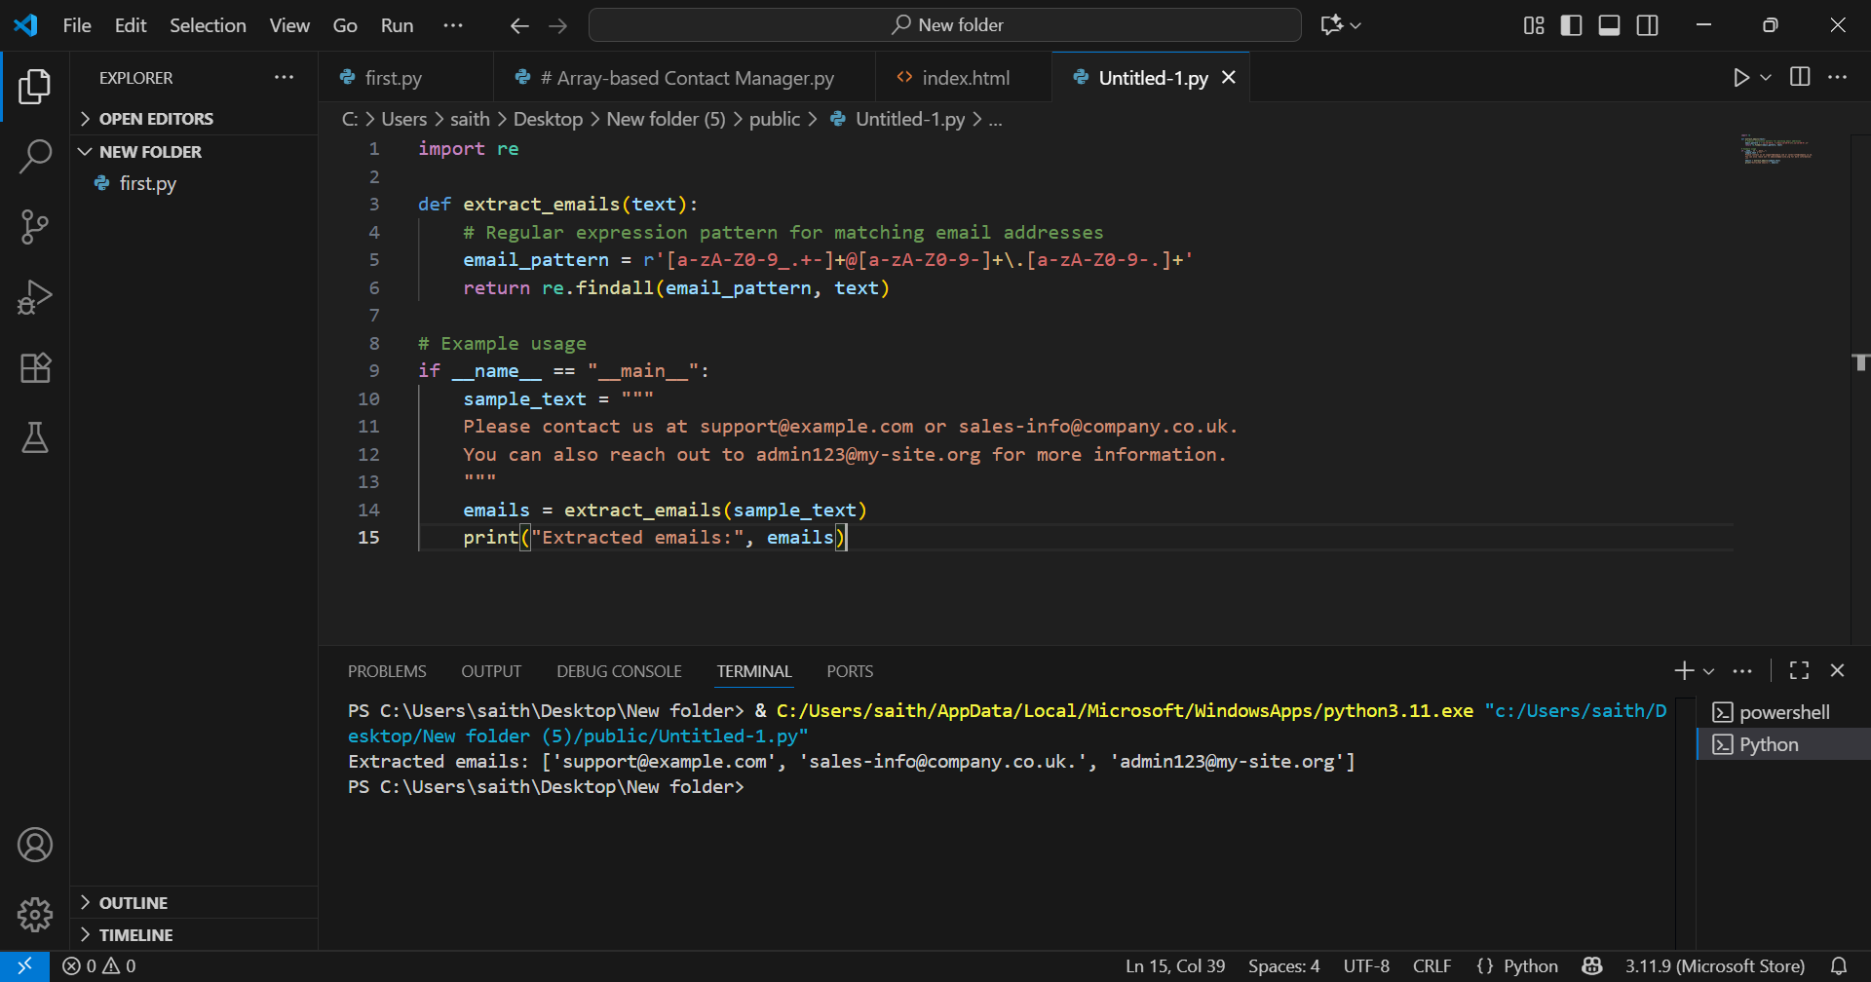

Github link: https://github.com/2403A53057/shwetha.git

